**Weather Forecast App**

Project submitted to the

SRM University – AP, Andhra Pradesh

for the partial fulfillment of the requirements to award the degree of

**Bachelor of Technology/Master of Technology**

In

**Computer Science and Engineering**

**School of Engineering and Sciences**

Submitted by

**Atharva Narkhede (AP21110011028)**

**Ankush Kumar (AP21110011026)**

**Rahul Bajaj (AP21110011022)**

**Prafull Raj (AP21110011016)**

Under the Guidance of

**(Poonam Yadav Ma’am)**

**SRM University–AP**

**Neerukonda, Mangalagiri, Guntur**

**Andhra Pradesh – 522 240**

**[December, 2022]**

# Certificate

Date: 14-Dec-22

This is to certify that the work present in this Project entitled “**Weather Forecast App**” has been carried out by **Atharva Narkhede** under my supervision. The work is genuine, original, and suitable for submission to the SRM University – AP for the award of Bachelor of Technology/Master of Technology in **School of Engineering and Sciences**.

**Supervisor**

(Signature)

Poonam Yadav

CSE Professor

SRM University AP

# Certificate

Date: 14-Dec-22

This is to certify that the work present in this Project entitled “**Weather Forecast App**” has been carried out by **Rahul Bajaj** under my supervision. The work is genuine, original, and suitable for submission to the SRM University – AP for the award of Bachelor of Technology/Master of Technology in **School of Engineering and Sciences**.

**Supervisor**

(Signature)

Poonam Yadav

CSE Professor

SRM University AP

# Certificate

Date: 14-Dec-22

This is to certify that the work present in this Project entitled “**Weather Forecast App**” has been carried out by **Ankush Kumar** under my supervision. The work is genuine, original, and suitable for submission to the SRM University – AP for the award of Bachelor of Technology/Master of Technology in **School of Engineering and Sciences**.

**Supervisor**

(Signature)

Poonam Yadav

CSE Professor

SRM University AP

# Certificate

Date: 14-Dec-22

This is to certify that the work present in this Project entitled “**Weather Forecast App**” has been carried out by **Prafull Raj** under my supervision. The work is genuine, original, and suitable for submission to the SRM University – AP for the award of Bachelor of Technology/Master of Technology in **School of Engineering and Sciences**.

**Supervisor**

(Signature)

Poonam Yadav

CSE Professor

SRM University AP

# Acknowledgements

We would like to thank our teachers and professors who gave us a chance to work on this project. We are very grateful that they provided valuable suggestions for the betterment of the project, which we greatly appreciate them for doing so.

Furthermore, we want to extend special thanks towards our college as well because without their resources then none of what is seen now could have been possible in terms of creative or intellectual development.

# Table of Contents

Certificates i-iv

Acknowledgements vi

Table of Contents viii

Abstract x

Abbreviations xii

List of Tables xiv

List of Figures xvi

1. Introduction 1

2. User Manual 3

3. Methodology 5

4. Conclusion 7

5. Future Work 9

References 11

# Abstract

Weather forecasting is mainly concerned with the prediction of weather condition in the given future time. Weather forecasts provide critical information about future weather. There are various approaches available in weather forecasting, from relatively simple observation of the sky to highly complex computerized mathematical models. The prediction of weather condition is essential for various applications. Some of them are climate monitoring, drought detection, severe weather prediction, agriculture and production, planning in energy industry, aviation industry, communication, pollution dispersal, and so forth. Accurate prediction of weather conditions is a difficult task due to the dynamic nature of atmosphere.

The weather condition at any instance may be represented by some variables. Out of those variables, one found that the most significant are being selected to be involved in the process of prediction. The selection of variables is dependent on the location for which the prediction is to be made. The variables and their range always vary from place to place. The weather condition of any day has some relationship with the weather condition existed in the same tenure of precious year and previous week. Rainfall is a form of precipitation. Its accurate forecasts can help to identify possible floods in future e and to plan for better water management. Weather forecasts can be categorized as: Now forecasts which is forecasts up to few hours, Short term forecasts which is mainly Rainfall forecasts is 1 to 3 days forecasts, Forecasts for 4 to 10 days are Medium range forecasts and Long term forecasts are for more than 10 days. Short range and Medium Range rainfall forecasts are important for flood forecasting and water resource management.

# Abbreviations

App Application

GUI Graphical User Interface

# List of Tables

Table 1. System Requirement…………………………………………………………….3

# List of Figures

Screenshot with features …………………………………………………..………………..1

# Introduction

**1.1 Overview**

Having an up-to-date information about the weather helps us to take well-read decisions. These weather apps constantly update the forecasts for a day or hour or sometimes for even a minute. These can be simply termed as the compact weather devices, as they do not only talk about the temperature of that specific region instead, they can describe the accurate time of the sunrise and sunset, the time of the rainfall, humidity levels, etc.

**1.2 Features**

The features of weather app are as follows:

1. Temperature
2. Description
3. Wind Speed
4. Humidity
5. Pressure
6. Visibility
7. UV Index
8. Clouds
9. Dew Point
10. Date and Day of that place
11. Time zone, Longitude and latitude of that place
12. Weather predictions for next 7 days giving day and night temperature.

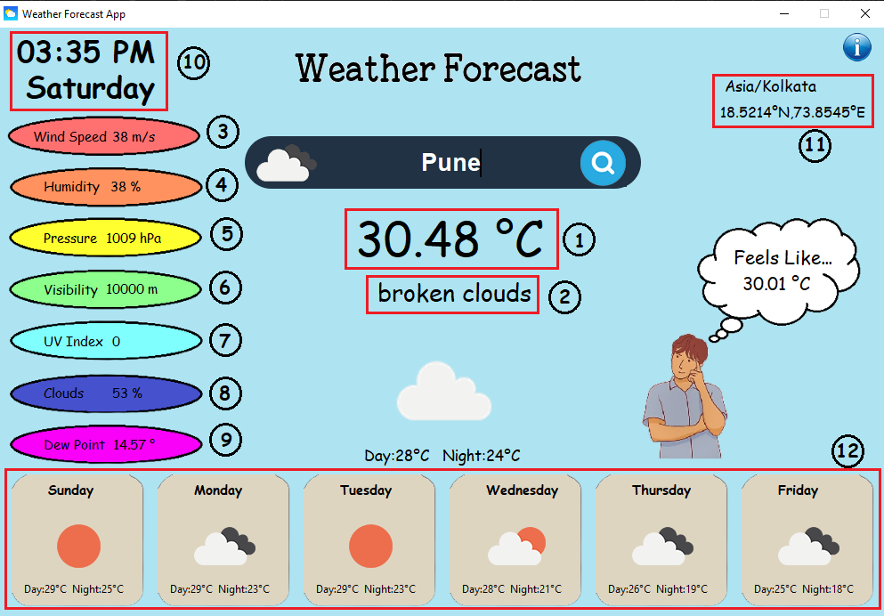

**1.3 Project Scope**

This application has ability to show weather forecast for a particular place. The project uses API call to receive the data in json format and print all the details accordingly.

**1.4 Limitations**

* The data provides is not 100% accurate and just provides the prediction of the weather.
* Sometimes the API to get weather details takes long time to respond which may delay in showing weather details.

# User Manual

**2.1 System Requirement**

The basic system requirement is

|  |  |  |
| --- | --- | --- |
| **Hardware /Software** | **Hardware /Software**  **Elements**  **Hardware /Software**  **Elements**  **Hardware /Software**  **Elements**  **Hardware /Software**  **Elements**  **Hardware /Software Elements** | **Specification/Version** |
| Hardware | Processor | Intel i3/i5/i7 or AMD |
| RAM | Min 4GB |
| HDD/SSD | Min 250 GB |
| Software | OS | Windows/ Linux/ Mac OS |
| Connectivity | Wi-Fi | Atleast 1 MBPS |

**2.2 Installation of Packages**

Firstly, you need to download the following packages

1. Step 1: Open cmd/terminal
2. Step 2: Run the following commands one by one
   1. pip install tk
   2. pip install geopy
   3. pip install timezonefinder
   4. pip install datetime
   5. pip install requests
   6. pip install pytz

**2.3 Working**

Step 1: Download the zip file from the link below

<https://drive.google.com/file/d/1lZm7bBPEPnnSiGEMgnrASsXfEU0iLEeI/view?usp=share_link>

Step 2: Extract the zip file downloaded

Step 3: Open the folder and search for file named PROJECT.py

Step 4: Right Click on the file and select open with Python

Step 5: Now the Weather Forecast Application will get opened

Step 6: Search for a place in the search box and hit enter or click on the search button.

Step 7: The Weather Forecast details will be displayed on your screen.

# Methodology

**Step 1:** The App asks user to input the name of a place.

**Step 2:** Then the App finds the timezone of that place using package timezonefinder.

**Step 3:** Then from the timezone data it gets current time of that place.

**Step 4:** Then using the timezone data in latitude and longitude, we make a API call.

**Step 5:** Using “requests” package we collect the received data in json format to further extract each and every detail from the file.

**Step 6:** After extracting data successfully from the file, we get the icon details from the file which is used to display weather condition icons such as sunny, snow, rain, etc.

**Step 7:** Finally, after all the processes the weather report is displayed on your computer screen.

# Conclusion

This Weather Forecast App Project was designed and developed using Python Programming language with concept of GUI.

This App enables user to get all basic details such as temperature, humidity, pressure, wind speed, clouds, UV index, etc.

# Future Work

* The weather app is having limited features and we will try to improve the GUI.
* We will try improving time required by API to receive data.
* Add multiple options such as graphs, daily alerts, desktop notifications, current weather at your location and much more.

# References

1. Tkinter concept from YouTube, <http://www.youtube.com>
2. API details and key from Openweathermap, [www.openweathermap.org/api](http://www.openweathermap.org/api)